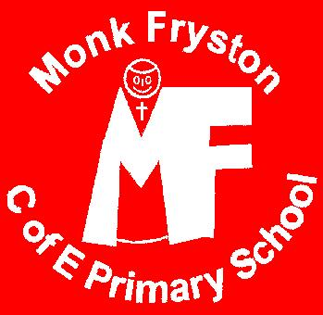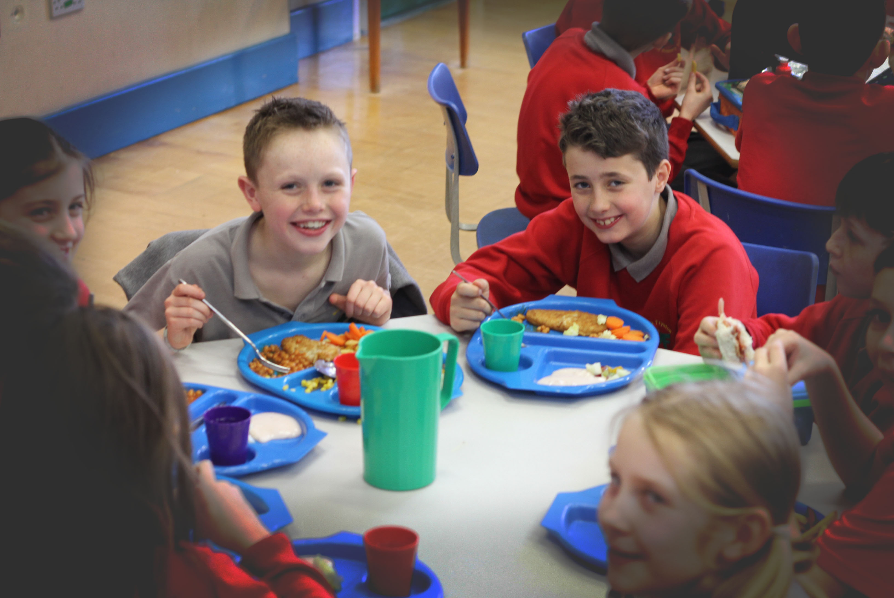

# School Meals at Monk Fryston CE Primary School

Provided by North Yorkshire County Caterers

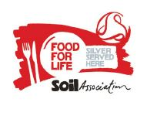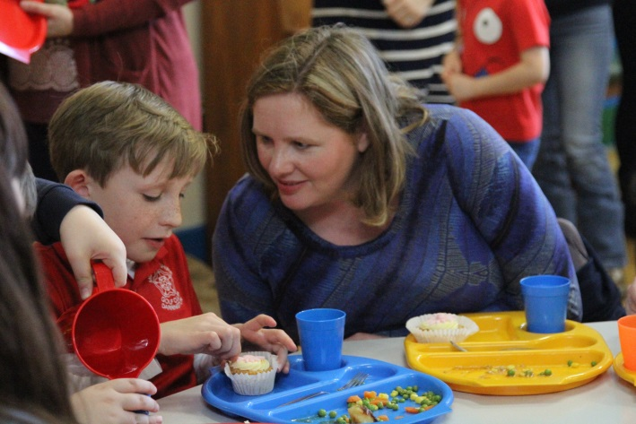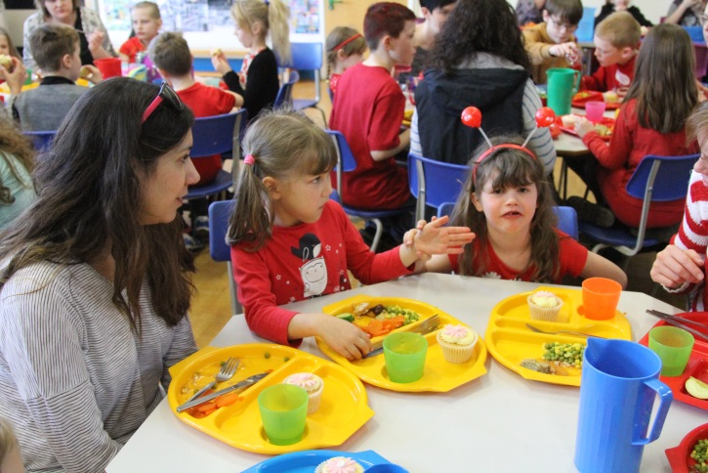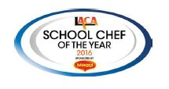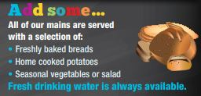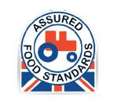

## Freshly Made

### By our cook, Mrs Butler

## Choices

Every day children are given a choice of dinners. They can choose to have the hot meal of the day, a jacket potato with a choice of toppings, or a sandwich. Every choice comes with extra salad from the salad bar, and the pudding of the day. Children can have as much salad as they wish so they can never go hungry!

All our meals are specially made on site. The ingredients are locally sourced and there are strict control measures to ensure that only the best ingredients are used. As a result, our kitchen consistently achieves high results on quality and hygiene inspections.

Each menu is prepared following carefully considered recipes. These identify the nutritional value of each dish to ensure that a healthy, balanced diet is achieved across the week. Portion sizes are carefully controlled to ensure that children receive the right amount of food to remain healthy, in line with medical advice and guidelines.

The Catering Service is accredited with the ‘Food for Life Served Here – Silver Award’ from the Soil Association, which is national recognition as a beacon of excellence in the provision of fresh, locally and regionally produced food. They pride themselves on their craft skills which are used every day in preparing nutritionally sound meals, catering for the dietary needs of children and young people. They provide the service in educational settings, so they make sure their staff are trained in safeguarding, equalities, and data protection.

They believe that a healthy, balanced diet is essential for children and young people so they provide fresh food that is cooked daily on school premises.

The catering service provides:

• A food safety management system which encompasses all aspects of food safety from procurement to service

• Menus which are compliant with nutritional standards and information for schools and parents with regards to allergens and special diets

• Staff who are trained and encouraged to develop their culinary skills  
  
Our school meals are:

• Nutritionally balanced

• Freshly prepared

• Made with local produce

• Adapted to meet dietary needs

• Changed every term to reflect the seasons

• Low-salt and low-sugar

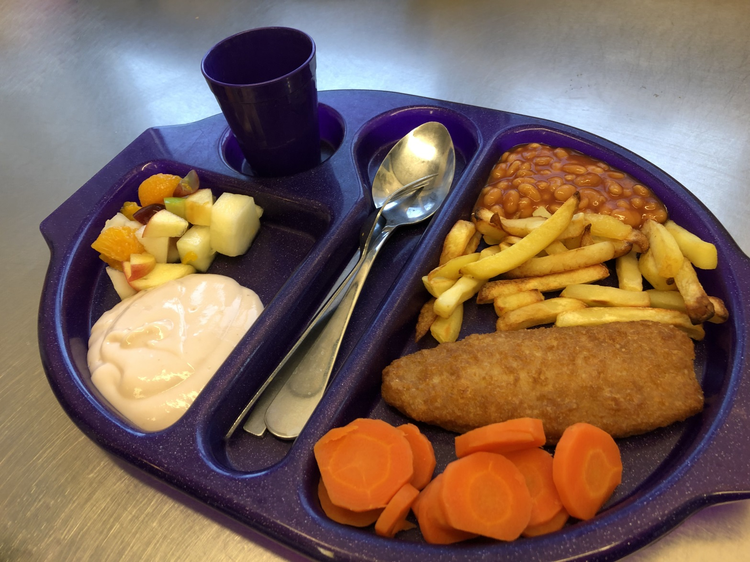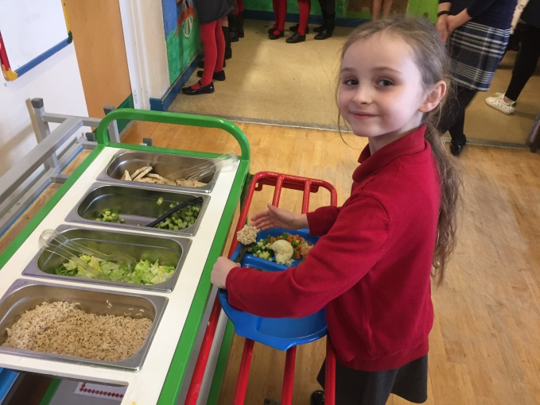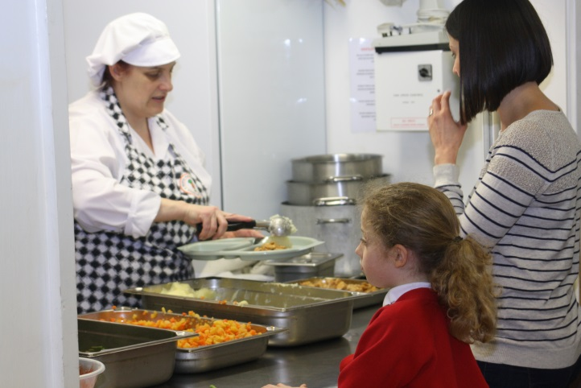

#### How are prices calculated?

The cost of our school meals is calculated very carefully to ensure that we maintain high standards whilst achieving excellent value for money.

The government provides funding that enables every child to receive a free meal until the end of Year 2. Families in receipt of benefits can apply to receive free meals at any age. We charge other pupils £2.30 per meal. This is an agreed price which applies across all schools in the STAR MAT and we believe that it represents excellent value. We ask children to book lunches for an entire week because this helps us to calculate the amount of food that needs to be ordered, helping us to reduce waste and keep costs down.

All menus have a calculated portion size which ensures that children receive the right amount of food to remain healthy. Because they all pay a fixed price, they all receive the same amount. This helps us to make sure that everybody is treated equally and fairly. We don’t usually offer ‘seconds’ because we control our ordering carefully, but children can always add bread or salad to their meal to make sure they have plenty to eat.

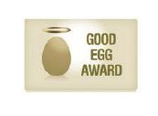

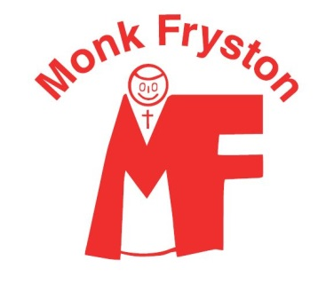

Our Year 4 children talked to their parents and grandparents about their experiences of school meals. They noticed quite a few changes!

*Parents & Grandparents’ experiences—this is what some people said:*

• “Main courses were: liver (from an animal) and onion, steak & kidney pie (with lamb kidney), lamb stew (carrots, lamb, onions and potatoes all cooked in a pan), boiled ham & pineapple, fish in parsley sauce.”

• “The school dinners were not as healthy as they are now. The healthiest choice was lasagne and chips.”

• “I hated prunes and custard because it was slimy”

• “We used to have Spam fritters”

• “We had tapioca pudding that looked like frogspawn”

• “Puddings usually had custard with them which wasn’t nice. Custard was often pink, or chocolate, or sometimes in winter it had rosehip syrup.”

• “Puddings were stodgy—we had Spotted Dick! It was horrible.”

#### How have dinners changed over time?

For more information about school meals please visit the North Yorkshire catering website:

<https://www.northyorks.gov.uk/school-meals>

#### Dinners today are different!

*Our Year 4 children think that our lunches sound better because:*

• “We have a variety of food and it is good to have a choice each day of the dinner, or a jacket potato, or a sandwich”

• “We have fruit and yoghurt for pudding which is healthier than custard puddings”

• “We really like the salad bar because it has lots of things on it that are healthy”

• “Our favourite dishes are Chicken Korma, Mac & Cheese, Pizza, and Mexican Tacos”

• “I love Tuna Baguettes!”

