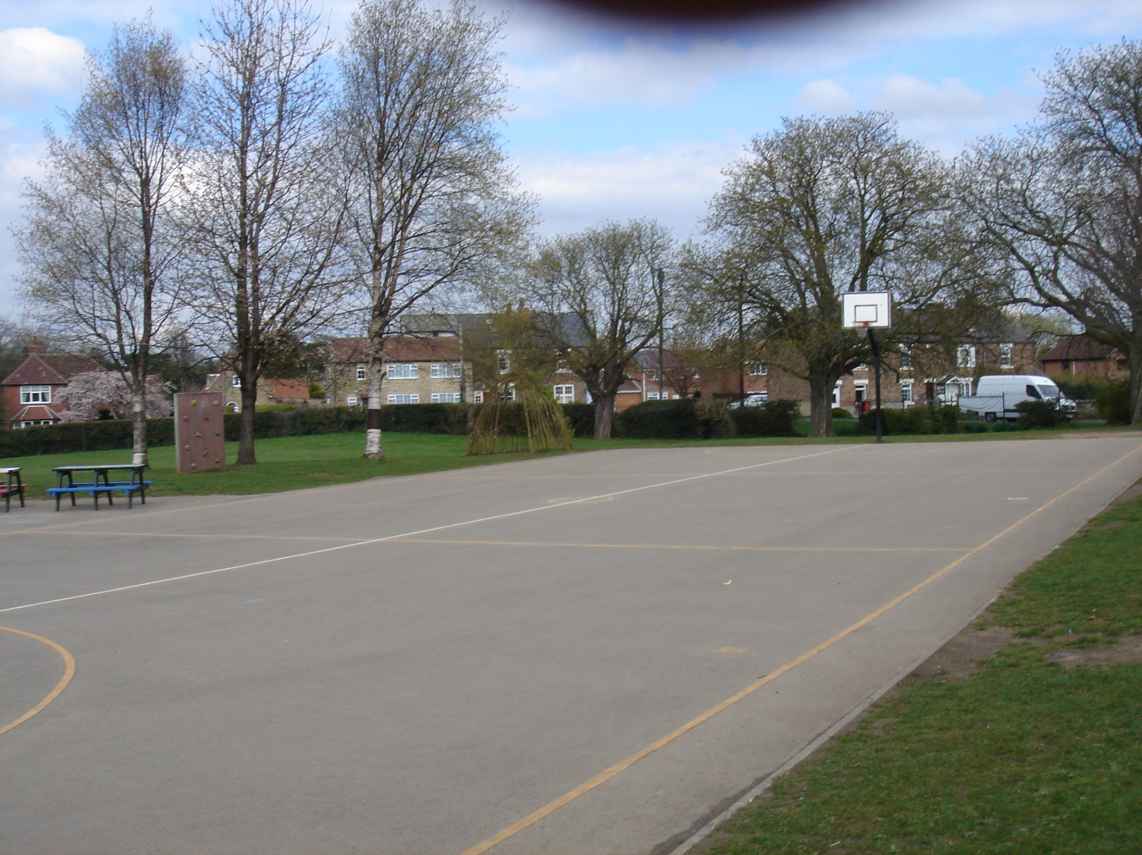
Monk Fryston Jets.

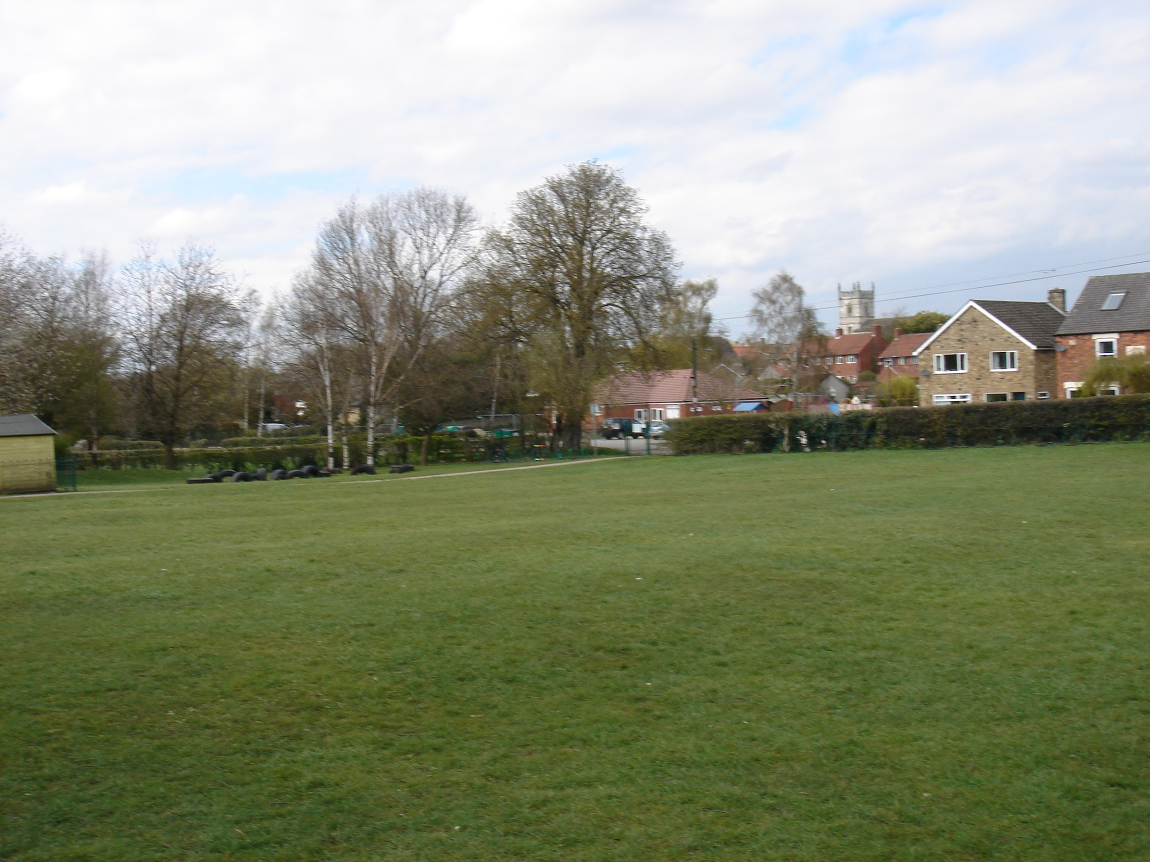
Come and try out this incredible, fun-filled, unisex football club. For all of you football mad kids, it will be perfect. The club is aimed at people with all sorts of disabilities.

Age: 7+

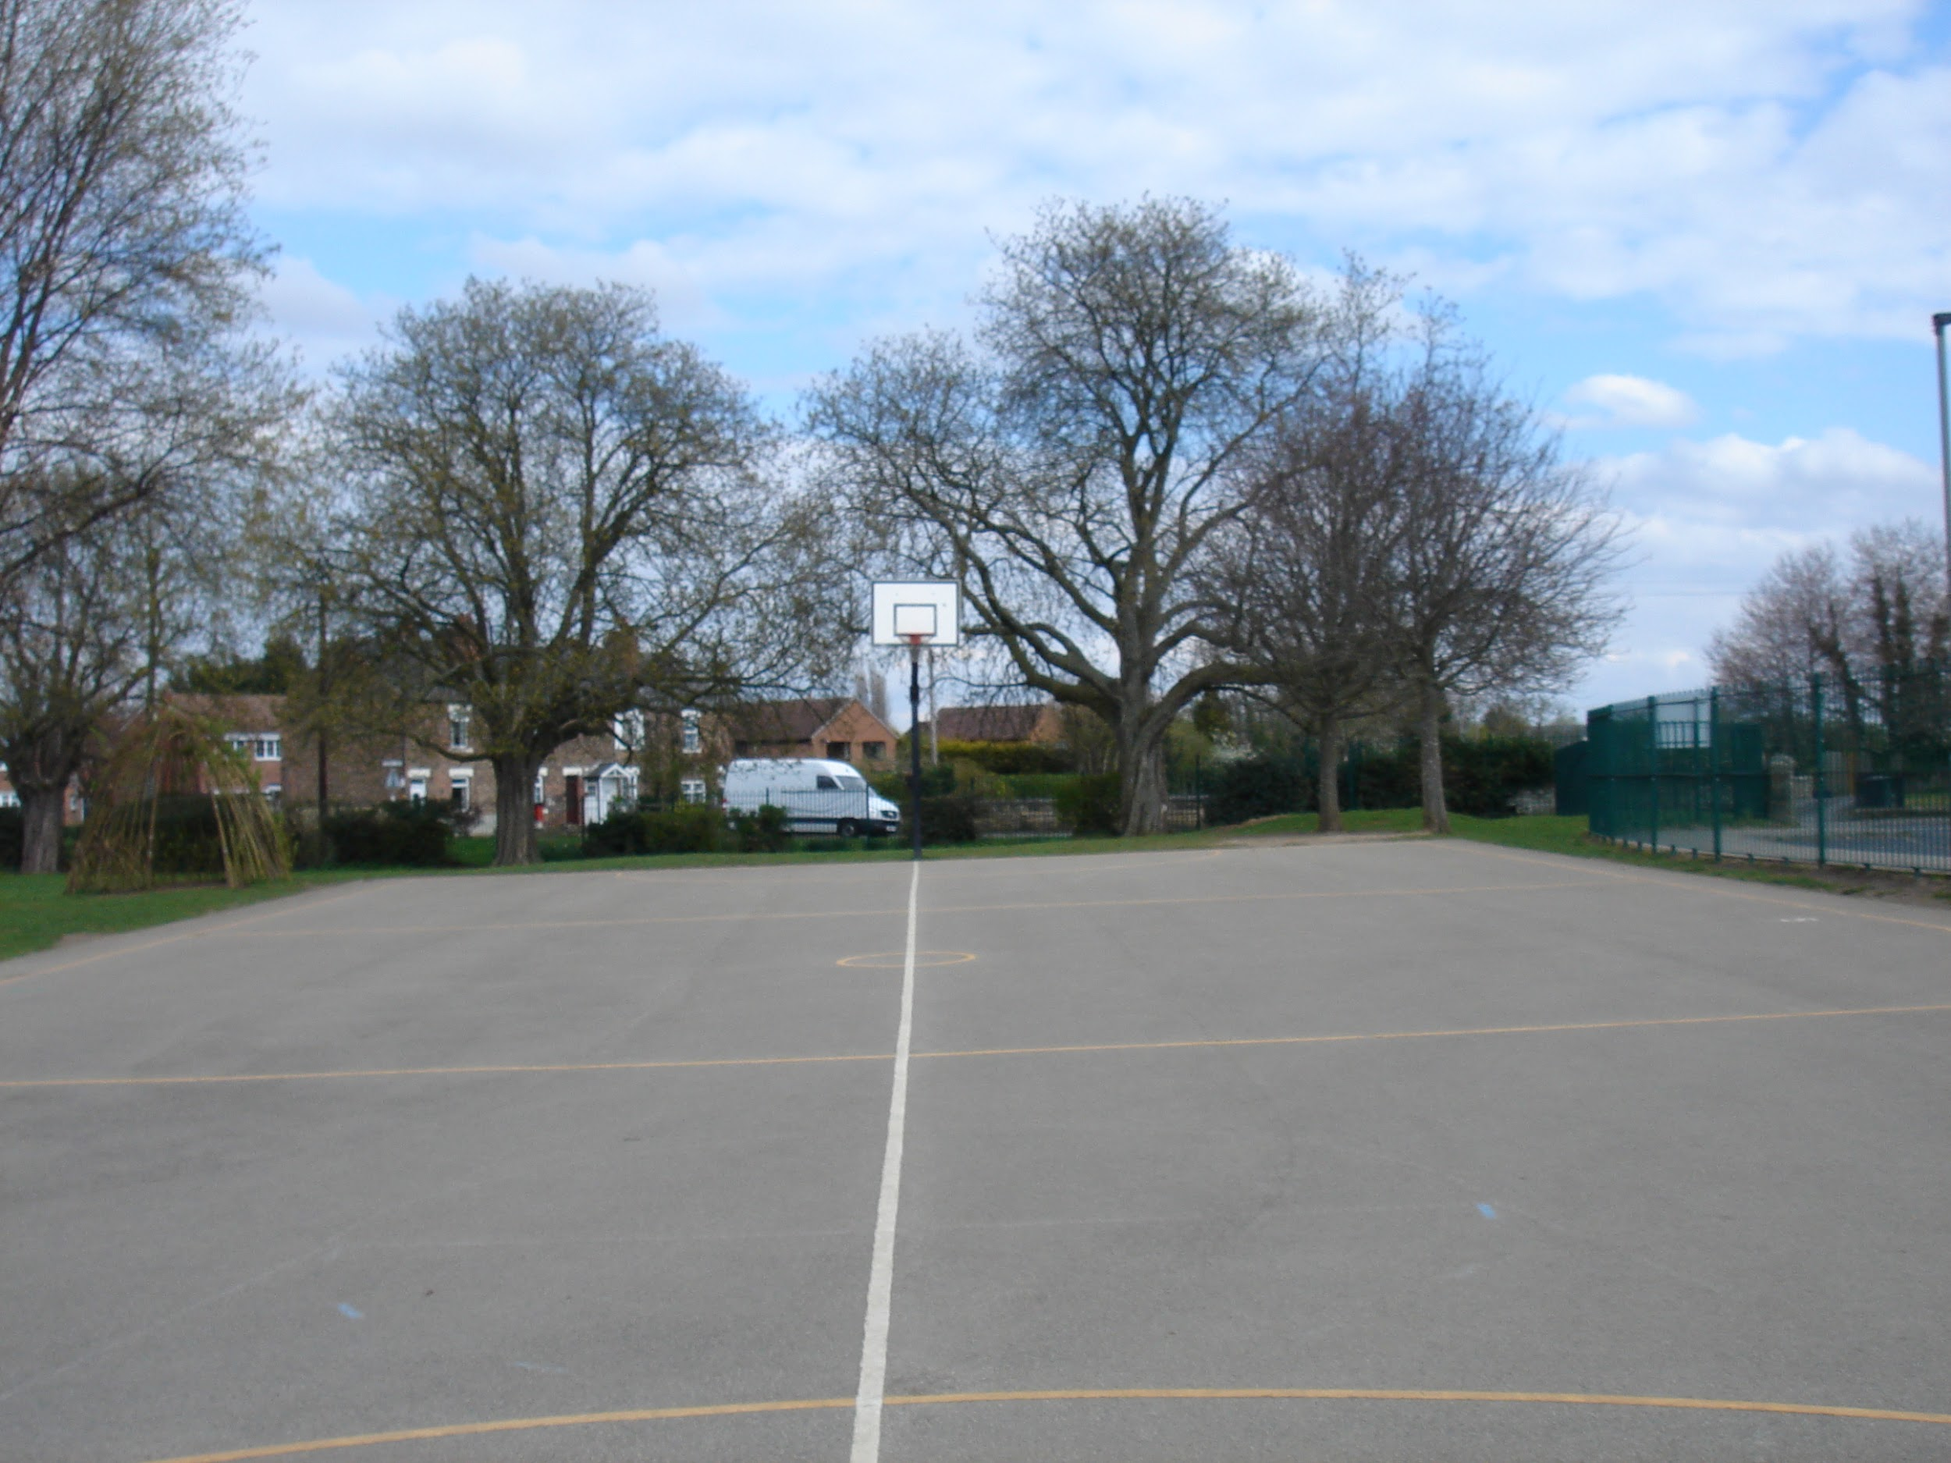
Place: Monk Fryston C of E Primary School, Monk Fryston.
When: Fortnightly on Fridays, 5pm - 7pm

Please contact Gabe
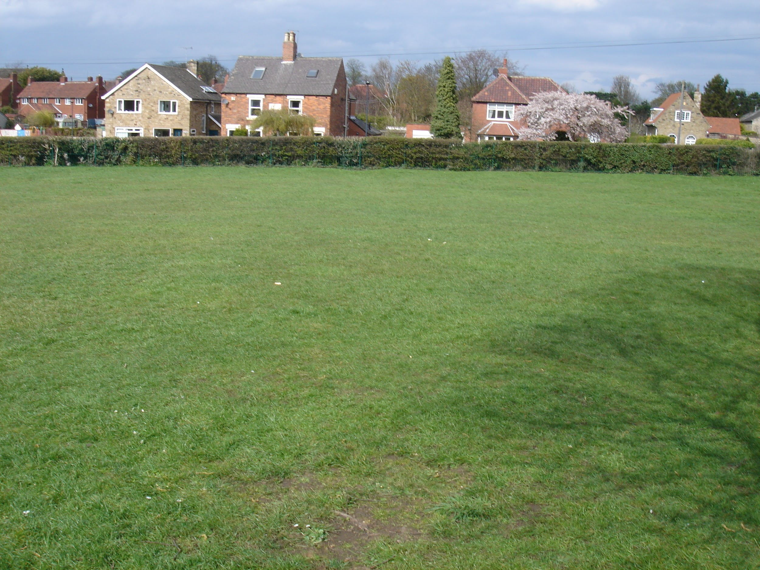
+07932724544 for more on how to get involved in this incredible football club and I hope to see you soon.

Hopefully your future coach,
Gabe Sheppard.

