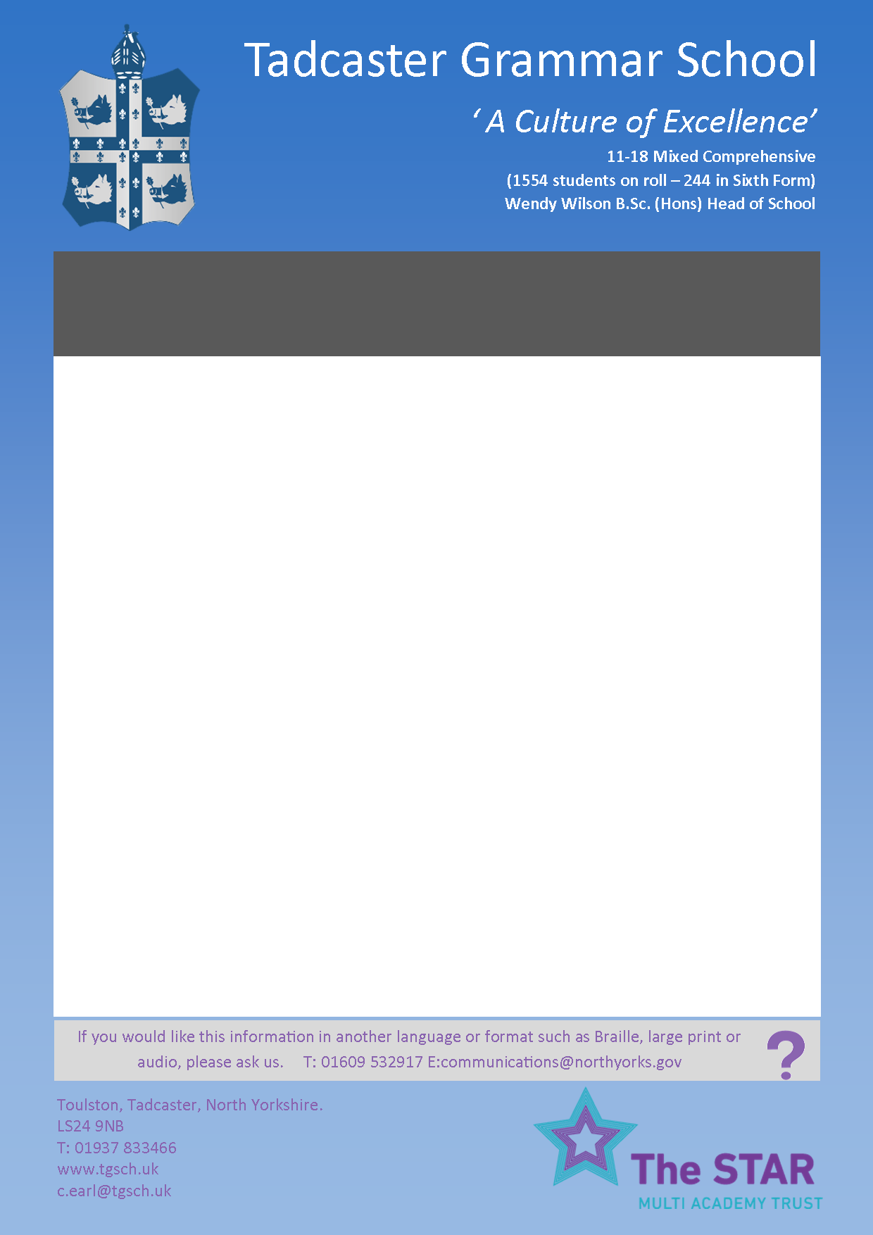

Required for September 2019, this is an exciting opportunity to join an expanding team of Teaching Assistants, and develop the provision and expertise offered by our Learning Support Faculty. We are looking for General Teaching Assistants who will be working 27.08 hours over 5 days a week (08:40 – 15:15 Monday to Friday) supporting students with a wide range of needs across the curriculum. Knowledge of techniques to improve performance, access and curriculum and challenge under-achievement are desirable. Previous experience of working with students who have learning, communication and social/emotional needs, is preferred, but not essential; opportunities for professional development will be available. This position is for one year in the first instance. Applications are welcomed from existing Teaching Assistants, both in mainstream and special school settings, or individuals new to the profession who are keen to make a difference to students with a high degree of need.

Tadcaster Grammar School is a fantastic place to work; we are offering a unique opportunity to be part of an enthusiastic team who are committed to enhancing the teaching and learning experiences for all our students, whatever their role in the organisation. TGS is part of the STAR Multi Academy Trust which is an exciting new venture strengthening our existing partnership with other local schools.

Please access the school’s website which contains full details of the post, together with an application form, which should be returned electronically to c.earl@tgs.starmat.uk or by post (marking the envelope ‘General Teaching Assistant Application’).

Candidates will be subject to an enhanced DBS check as part of our commitment to safeguarding.

***Applications should be returned by 12 noon on Wednesday 5 June 2019 and interviews will be held Thursday 13 June 2019***

For more information please visit our website: [www.tgs.starmat.uk](http://www.tgs.starmat.uk)

**GENERAL TEACHING ASSISTANTS**

**Salary Grade C, points 2-4 (£11,013 - £11,458)**

**27.08 hours per week (Term time only)**