Star Multi-Academy Trust Proposals – Consultation Questionnaire 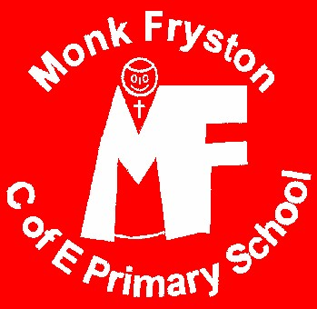
As part of the consultation process, schools need to obtain the views of interested parties for consideration. We would be grateful if you would please take a few minutes to complete this form and return it to your/your child’s school (if staff member or parent/carer) or your nearest school if a local resident, or via email to STAR-MATProjectTeam@mfschool.net There will be a public consultation event at Tadcaster Methodist Church on 22nd January, 18.30 to 20.00. Please return by January 26 2018 at the very latest.
I am: please tick the option(s) which best describe you
A parent/carer at Appleton Roebuck |  | A member of staff at Appleton Roebuck |  | Do you agree that your school (where appropriate) should convert to an Academy?
A parent/carer at Kellington |  | A member of staff at Kellington |  | Strongly agree
A parent/carer at Kirk Fenton |  | A member of staff at Kirk Fenton |  | Agree
A parent/carer at Monk Fryston |  | A member of staff at Monk Fryston |  | Disagree
A parent/carer at Riverside |  | A member of staff at Riverside |  | Strongly disagree
A parent/carer at Sherburn High |  | A member of staff at Sherburn High |  | Don’t know
A parent/carer at Sherburn Hungate |  | A member of staff at Sherburn Hungate |  | Please add further detail here if you would like to do so
A parent/carer at South Milford |  | A member of staff at South Milford
A parent/carer at Tadcaster Grammar |  | A member of staff at Tadcaster Grammar
A local resident |  | An employee of the local authority |  | Other: please specify
Do you have any comments to add, or questions to ask? Please expand the box or write on the other side of the page if you need to.

Thank you for your time. If you would like a reply to a question, please write your name and contact details (email address if possible) below this line:

