Tuesday 29th May 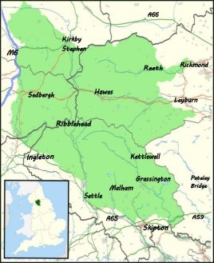
10am-3pm
Explorer’s Club – Active day.

Lots of nature- based activities for intrepid explorers aged 6-11 including orienteering, shelter building and crafts.
No adults allowed!

£15, £12 for second and subsequent siblings

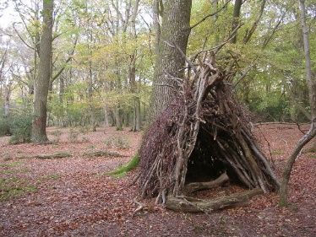
Booking essential.
Please bring a packed lunch.

www.yorkshirearboretum.org

Booking via The Yorkshire Arboretum website or telephone The Visitor Centre on 01653 548598

