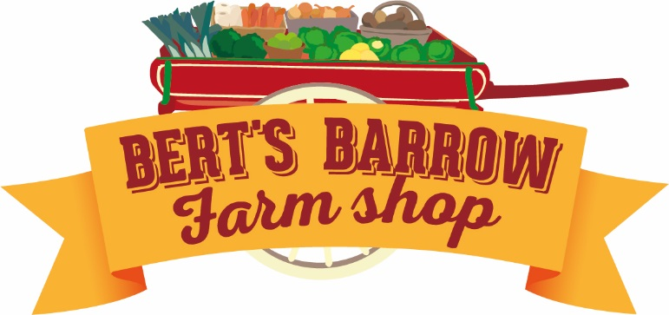
04.09.2019
Hello All!

We are running an event at Bert’s Barrow on 27th September from 4pm until 9pm in order to raise money for your school! It will be Pizza night featuring Knead n Feed & our first annual cider making festival! We will be taking donations on the night to raise money for your school – but we can’t make cider without apples!

Who has loads of apples and every year find they just get wasted on the floor? We have teamed up with Yorkshine Spirit from South Milford & we are all going to be making cider in the traditional way using an apple cider press, but we need your apples - LOTS & LOTS of them! We will then let them ferment and you can taste your home grown cider in the spring!!!!

We have set up an apple drop off point here at Bert’s from now until the night so bring your apples and let’s have some fun and raise some money for our local primary schools - Monk Fryston, Burton Salmon, Hambleton & South Milford.

We will not charge to make the cider or to try it in spring, but we will ask for money donations on the night and split it between the schools in the spring when we have our tasting night.

It will be busy so if you’re wanting to have pizza on the night, we have time slotted the oven - tickets cost £1 to guarantee your space in the oven & to pay to heat the barn etc. Head over to https://www.wegottickets.com/event/482238 to buy your tickets!

We look forward to seeing you soon, raising funds for the local schools & having a go at an old tradition as well as not wasting those fabulous apples!!!

Love,

Team Bert’s x

