A VIKING IN OUR VILLAGE
You are invited to our open afternoon a pre - Christmas treat featuring displays on Hillam Hall, Hillam Enclosure, Byram Park, the new Burton Salmon Village Trail, Brewing history in our Villages, Monk Fryston Heritage Trail, Monk Fryston Hall and the Hemsworth Family and recent archaeology work done there.
COME AND MEET A REAL VIKING AND HEAR WHAT LIFE WAS LIKE HERE IN OUR VILLAGES DURING DANELAW

VIEW PAST ASPECTS OF LIFE IN BURTON SALMON, HILLAM AND MONK FRYSTON VILLAGES OVER THE CENTURIES

TIME TEAM WILL DISPLAY THEIR ARCHIVES AT THIS OPEN MEETING

BRING YOUR QUESTIONS AND MEMORIES TO ADD TO OUR RECORDS

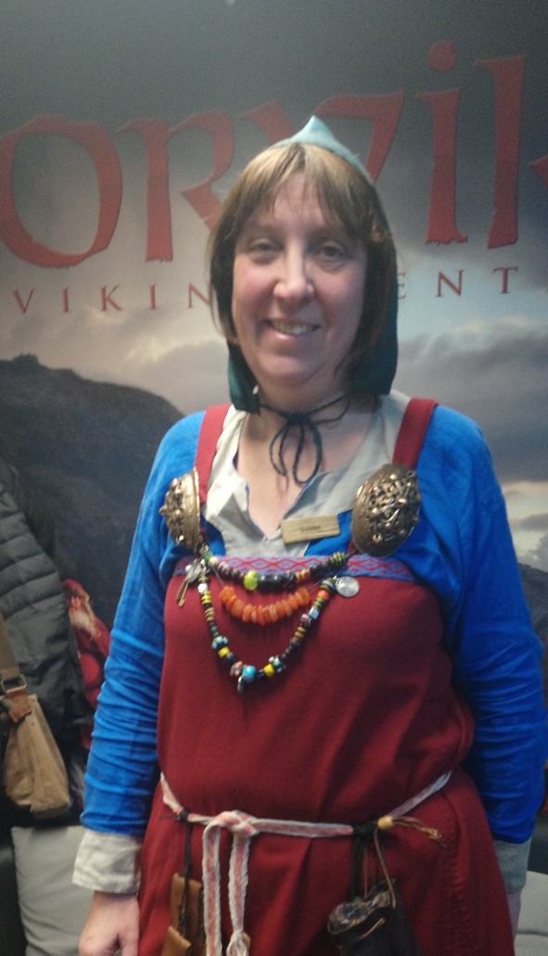
ALL AGES WELCOME
SUNDAY DECEMBER 8TH from 2 to 4 pm at the
COMMUNITY CENTRE Old Vicarage Lane Monk Fryston

