**HILLAM RINGTREE LIGHTS**

**Join us in The Square, Hillam on Saturday 7th December 6:30pm**

**for mince pies, mulled wine, hot soup, carol singing –**

**and a visit from Father Christmas!**

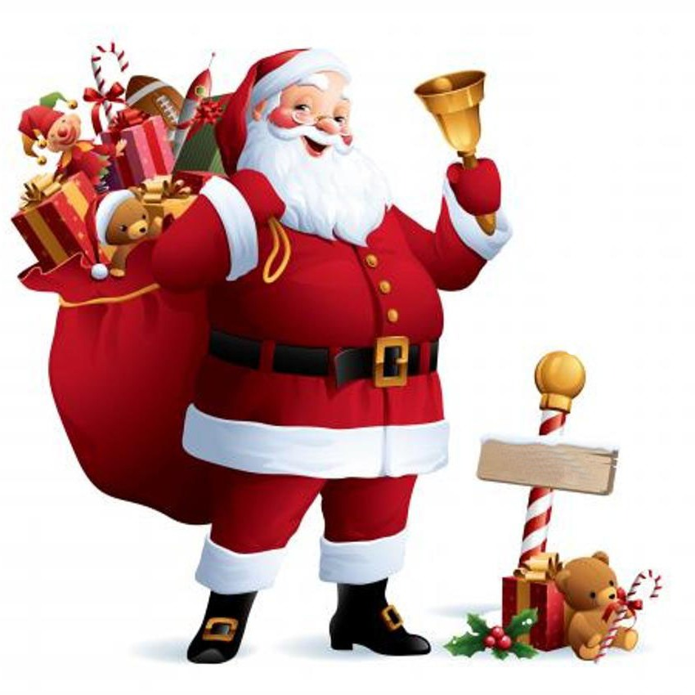

hillamlights@gmail.com

