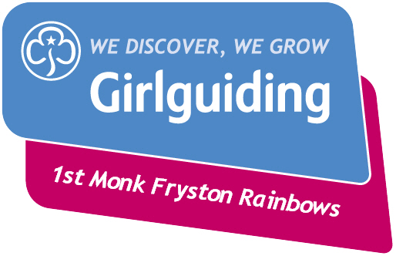

Have you thought about volunteering in your community? Maybe 2020 is the time to get started! 1st Hillam and Monk Fryston Rainbows are in desperate need of adult helpers. We would love for you to get involved and give however much time you have, whether that is coming to Rainbows once a month or coming every week. You don’t need any experience and you don’t need to have been a Rainbow or Brownie before.
Rainbows are the youngest members of our Girlguiding family aged 5 to 7 and we meet on a Friday from 4.45pm for an hour. We get up to all sorts of activities including cooking, crafts, science, learning new skills, games and having fun.
Getting involved in Girlguiding is really rewarding and lots of fun – it is fantastic to watch the girls learn and grow, develop in confidence and make new friends. And its great for your CV too!
Please get in touch if you want to find out more and share with your family and friends in case they might be interested.
Looking forward to hearing from you!
Marie Parkin – 1st Hillam and Monk Fryston Rainbows Leader – 07887 608604.
marie.parkin@totalenterprisesolutions.co.uk

