Monk Fryston CE Primary School  Part of the STAR Multi-Academy Trust | The Values of Our School  Monk Fryston CE Primary School

This booklet contains our new school values. These explain what our school stands for and underpin our actions and decisions.

During 2018 – 2019, staff and governors reviewed our aims and values. We rooted each statement in a biblical context in line with our Church foundation, and tried to articulate them in statements that are concise and memorable. To help children to remember these, each statement has been associated with an illustration or quote from a book.
.

We have structured our values statements in the form of a book. When your child starts in our school, their learning story begins and we develop the values with them throughout their school life.  Although every value is its own ‘chapter’, we will keep teaching and reinforcing them all throughout every year that your child is in school.  We believe that our values help to shape our thinking, and your child’s education. If these values have importance in the ways that we teach and behave, we will achieve our aim of ‘Good people, doing well’. |  |  | We would welcome your support in discussing these values with your child so that they understand what they mean and know how they can enact them in school.  Look Up! Aim High!
This is our school, where a child’s learning story begins. We all take ownership and share a collective responsibility to love and care for everyone here.
We will be better and stronger, because we are working together in our quest to do and be our best.
Romans 8:28
²⁸ We know that in all things God works for good with those who love him, those whom he has called according to his purpose.

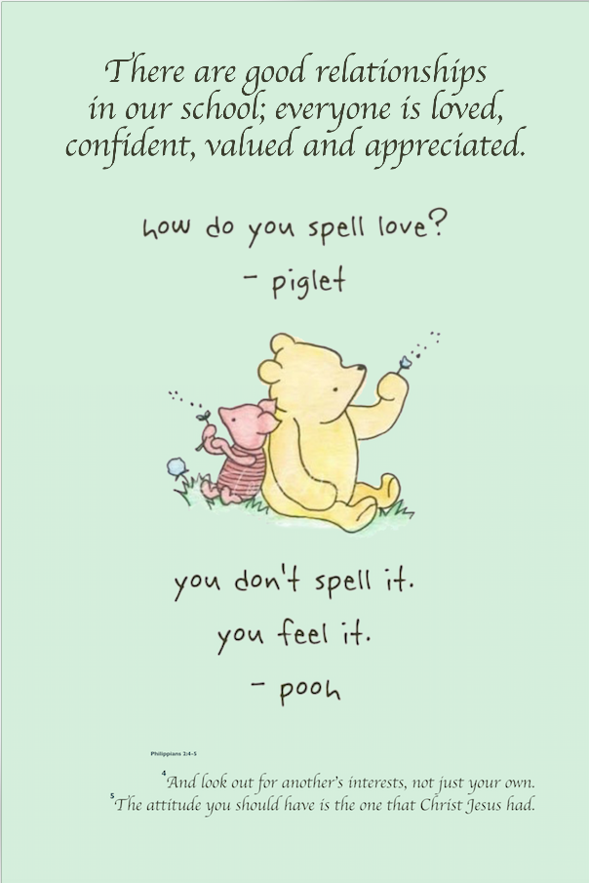 |  | 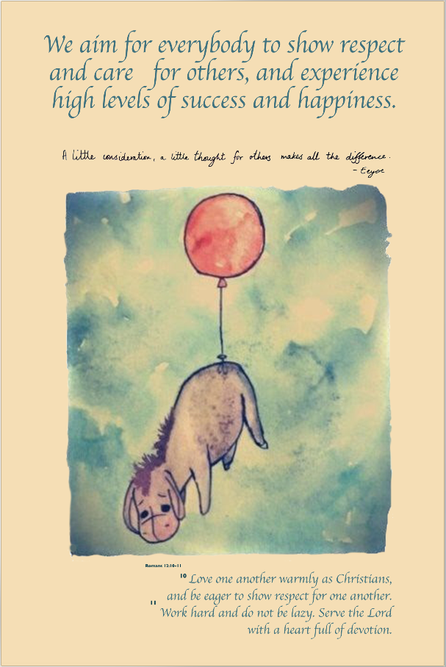
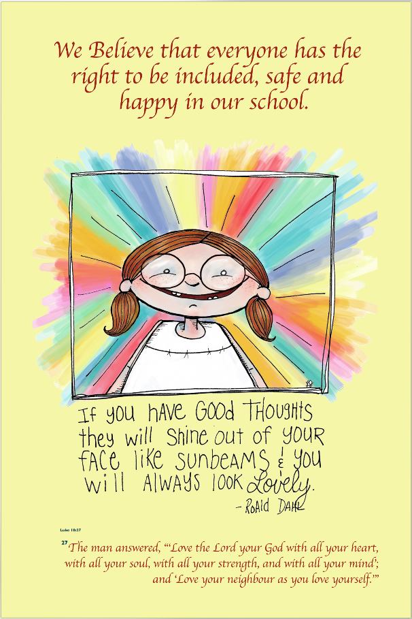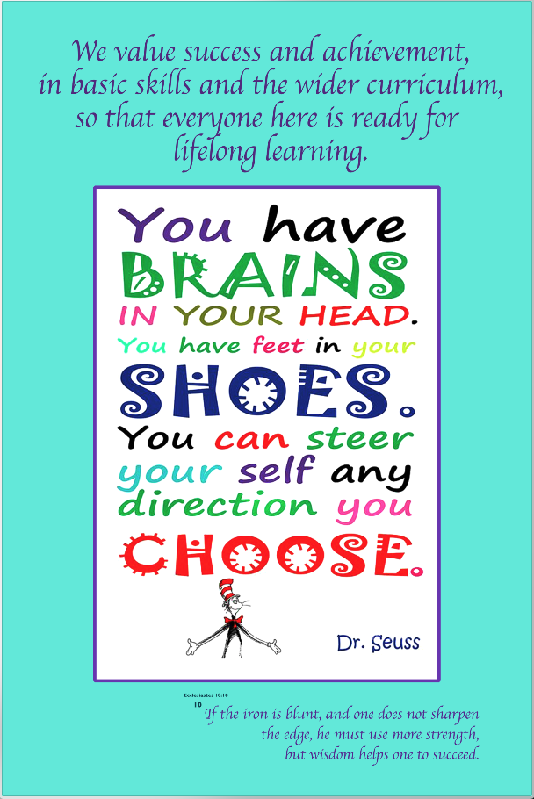
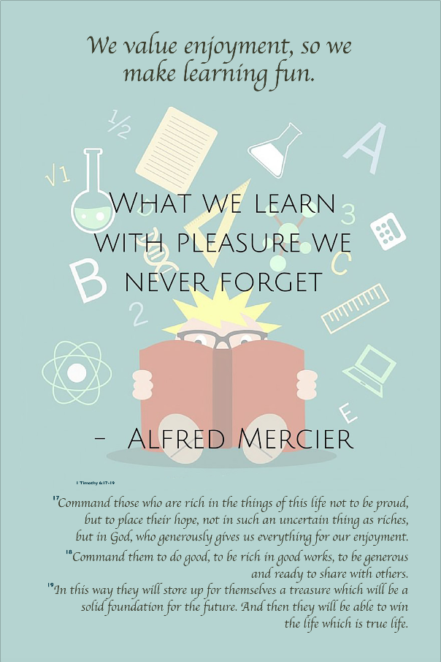 |  | 