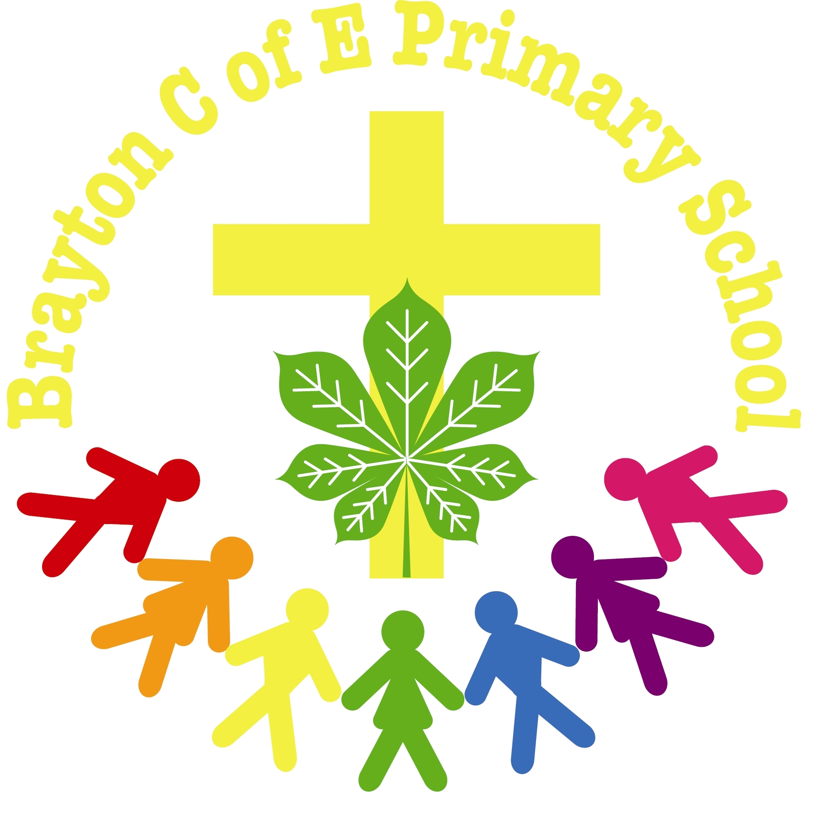


Headteacher: Mrs Rachel Robinson
Contract: Deputy Headteacher, Established Full Time 1.0 FTE
Salary Range: L9 - L13 Start Date: September 2021

In the picturesque village of Brayton, our Church of England Primary School stands in pride of place behind the village green. We are growing in numbers and have rising standards. We are proud to be a member of the Star Multi Academy Trust.
This is an exciting opportunity to work closely with a dedicated staff team and an experienced, visionary Headteacher to take our school to the next level. We are looking for a Deputy Head who can motivate, inspire and challenge our team to provide the highest standards of teaching to our children and enhance learning with enjoyable experiences.
Brayton C of E Primary has a Church School ethos and a dedicated, friendly team. We have a developing environment with hard-working, enthusiastic, and endearing pupils. We are aspirational for our children and staff and are determined to continue on our improvement journey.
Our ideal candidate will be:
• An excellent teacher and role model with experience of curriculum development
• A considerate team player who puts children at the heart of all decisions
• A leader with experience of positively impacting on whole school pupil progress
• A highly organised professional with excellent interpersonal skills
• A supportive mentor with an interest in co-ordinating support for those students with special educational needs
• A confident user of ICT with successful experience of using data and assessment to maximise outcomes.
This position would suit an experienced Deputy Head or an aspiring Deputy with the requisite skills and with successful experience with a ‘whole school’ responsibility.
If you would like to visit the school or you require further information, please call the School Business Manager, Adele Mulvey. Application forms should be returned via email to admin@bp.starmat.uk.
Visits are welcomed and strongly encouraged and are subject to COVID restrictions.
Closing date: 7th May 2021 – 4pm
Interviews: 18th and 19th May 2021
Brayton Church of England Primary School is committed to safeguarding children and successful candidates will be subject to an Enhanced DBS check and satisfactory reference checks. Our commitment to safeguarding is underpinned by consistently robust processes and checks.

